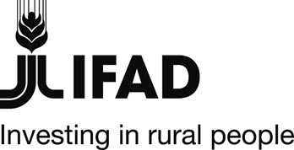

Corrigendum

RESOLVE: Results based management for rural transformation

Corrigendum
The attention is drawn to the following corrigendum to the documents "Letter of invitation RESOLVE" and "Project Description RESOLVE." For ease of reference, the changes to the documents are shown in boldface.
Page 3, Letter of Invitation RESOLVE:
the deadline for submitting your application is 1 March 2020 (12:00 CEST) should read:
“the deadline for submitting your application is 1 March 2020 (12:00 Rome time)”

Page 4, Project Description RESOLVE
The Deadline for submitting the proposal is: 1 March 2020 (12:00 CEST) should read:
“The Deadline for submitting the proposal is: 1 March 2020 (12:00 Rome Time)”

